**Simply Explained Logistic Regression with Example**



With that being said, let’s get started. We know that a liner model assumes that response variable is normally distributed. We have equation of the form *Yi = β0 + β1X+ εi,*where we predict the value of Y for some value of X. We know this is linear because for each unit change in X, it will affect the Y by some magnitude *β1. Also,*the error term*εi is*assumed to be normally distributed and if that error term is added to each output of Y, then Y is also becoming normally distributed, which means that for each value of X we get Y and that Y is contributing to that normal distribution. Now, this is all good when the value of Y can be -∞ to + ∞, but if the value needs to be TRUE or FALSE, 0 or 1, YES or No then our variables does not follow normal distribution pattern. All we have is the counts of 0s and 1s which is only useful to find probabilities for example say if you have five 0s and fifteen 1s then getting 0 has probability of 0.25 and getting 1 has the probability of 0.75. But how can we use that probability to make a kind of smooth distribution that fits a line (Not linear) as close as possible to all the points you have, given that those points are either 0 or 1.

To do that you have to imagine that the probability can only be between 0 and 1 and when you try to fit a line to those points, it cannot be a straight line but rather a S-shape curve.

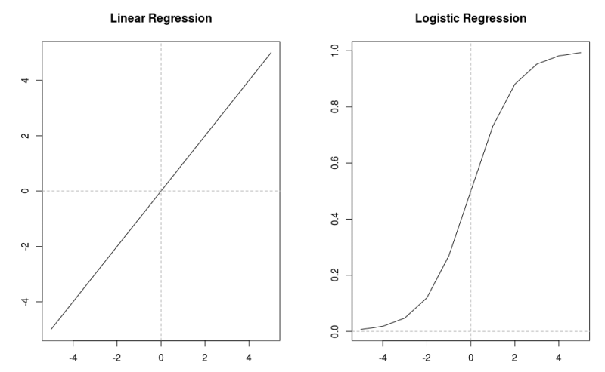

Linear vs Logistic

If you have a greater number of 1s then that S will be skewed upwards and if you have greater numbers of 0s then it will be skewed downwards. Note that the number 0 on Y-axis represents that half of the counts of total number is on left and half of total count is on right, but it cannot be the case always.

Now the question arises, how do we map binary information of 1s and 0s to regression model which uses continuous variables? The reason we do that mapping is because we want our model to be capable of finding the probability of desired outcome being true. Below I am going to describe how we do that mapping. Keep in mind that the main premise of logistic regression is still based upon a typical regression model with a few methodical changes.

Now, to find the probability of desired outcome, two things we must always be followed.

1- That the probability can not be negative, so we introduce a term called exponential in our normal regression model to make it logistic regression.

2- Since the probability can never be greater than 1, we need to divide our outcome by something bigger than itself.

And based on those two things, our formula for logistic regression unfolds as following:

1. Regression formula give us Y using formula *Yi = β0 + β1X+ εi.*

2. We have to use exponential so that it does not become negative and hence we get P = exp(*β0 + β1X+ εi*).

3. We divide that P by something bigger than itself so that it remains less than one and hence we get P = e(*β0 + β1X+ εi*)**/**e(*β0 + β1X+ εi*) +1.

4. After doing some calculations that formula in 3rd step can be re-written as log(p**/**(1-p)) =*β0 + β1X+ εi.*

5. log(p**/**(1-p)) is called the odds of probability. If you look closely it is the probability of desired outcome being true divided by the probability of desired outcome not being true and this is called logit function.

P(x)=1/1+e(-x) Sigmoid o or 1(Logistic Regression)

X=Linear regression( *β0 + β1X+ εi)*

Working:

When you calculate total number of 1s and 0s you can calculate the value of log(p**/**(1-p)) quite easily and we know that this value is equal to *β0 + β1X+ εi.*Now you can put that value into the formula P = e(*β0 + β1X+ εi*)**/**e(*β0 + β1X+ εi*) +1 and get the value of P. That P will be the probability of your outcome being TRUE based on some given parameters.

From a different perspective, let’s say you have your regression formula available with intercept and slope already given to you, you just need to put in the value of X to predict Y. But you know in logistic regression it doesn’t work that way, that is why you put your X value here in this formula P = e(*β0 + β1X+ εi*)**/**e(*β0 + β1X+ εi*) +1 and map the result on x-axis and y-axis. If the value is above 0.5 then you know it is towards the desired outcome (that is 1) and if it is below 0.5 then you know it is towards not-desired outcome (that is 0).

A little bit of touch to Exponent’s functionality

Let say you have invested a dollar somewhere. Now in a year it will grow 50% of its previous value, so in 2018 if it was $1 then in 2019 it becomes $1.5 and in 2020 it becomes $2.25. Why 2.25? Because $1 gave birth to 0.5$ and that 0.5$ starts earning its own interest which is 0.25 and as the time goes by the sprout of each sprout keeps earning its own interest and that it why we have that S-shape curve shown above.

Threshold-0.5>1 true <0.5=0 False

0.25 f

0.53 t

0.45 f

0.75 t

Example

Things to keep in mind,

1- A linear regression method tries to minimize the residuals, that means to minimize the value of ((mx + c) — y)². Whereas a logistic regression model tries to predict the outcome with best possible accuracy after considering all the variables at hand.

2- It calculates the probability of each point in dataset, the point can either be 0 or 1, and feed it to logit function.

3- The coefficients we get after using logistic regression tell us how much that particular variables contribute to the log odds.

The source of the data is from UCLA which has 4 variable called admit, GRE score, GPA and rank of their undergrad school. Our aim is to build a model so that predict the probability of that student getting admit if we are given his profile.

df <- read.csv(“https://stats.idre.ucla.edu/stat/data/binary.csv")  
 str(df)  
 ## ‘data.frame’: 400 obs. of 4 variables:  
 ## $ admit: int 0 1 1 1 0 1 1 0 1 0 …  
 ## $ gre : int 380 660 800 640 520 760 560 400 540 700 …  
 ## $ gpa : num 3.61 3.67 4 3.19 2.93 3 2.98 3.08 3.39 3.92 …  
 ## $ rank : int 3 3 1 4 4 2 1 2 3 2 …

We see that variable are either integer or number.

sum(is.na(df))## [1] 0

No null values

summary(df)## admit gre gpa rank   
 ## Min. :0.0000 Min. :220.0 Min. :2.260 Min. :1.000   
 ## 1st Qu.:0.0000 1st Qu.:520.0 1st Qu.:3.130 1st Qu.:2.000   
 ## Median :0.0000 Median :580.0 Median :3.395 Median :2.000   
 ## Mean :0.3175 Mean :587.7 Mean :3.390 Mean :2.485   
 ## 3rd Qu.:1.0000 3rd Qu.:660.0 3rd Qu.:3.670 3rd Qu.:3.000   
 ## Max. :1.0000 Max. :800.0 Max. :4.000 Max. :4.000

We can notice that there are a greater number of rejects than there are acceptance since the mean of variable admit is less than “0.5”.

xtabs(~ admit +rank ,data=df) ## rank  
 ## admit 1 2 3 4  
 ## 0 28 97 93 55  
 ## 1 33 54 28 12

We do this to check if the admits are distributed well enough in each category of rank. If let’s say one rank has only 5 admit or reject information, then it will not be necessary to include that rank in analysis.

Now we run our logit function, but before that we also have to convert rank variable from integer to factor.

df$rank <- as.factor(df$rank)  
   
 logit <- glm(admit ~ gre+gpa+rank,data=df,family="binomial")  
   
 summary(logit)##   
 ## Call:  
 ## glm(formula = admit ~ gre + gpa + rank, family = "binomial",   
 ## data = df)  
 ##   
 ## Deviance Residuals:   
 ## Min 1Q Median 3Q Max   
 ## -1.6268 -0.8662 -0.6388 1.1490 2.0790   
 ##   
 ## Coefficients:  
 ## Estimate Std. Error z value Pr(>|z|)   
 ## (Intercept) -3.989979 1.139951 -3.500 0.000465 ***  
 ## gre 0.002264 0.001094 2.070 0.038465 *   
 ## gpa 0.804038 0.331819 2.423 0.015388 *   
 ## rank2 -0.675443 0.316490 -2.134 0.032829 *   
 ## rank3 -1.340204 0.345306 -3.881 0.000104 ***  
 ## rank4 -1.551464 0.417832 -3.713 0.000205 ***  
 ## ---  
 ## Signif. codes: 0 '***' 0.001 '**' 0.01 '*' 0.05 '.' 0.1 ' ' 1  
 ##   
 ## (Dispersion parameter for binomial family taken to be 1)  
 ##   
 ## Null deviance: 499.98 on 399 degrees of freedom  
 ## Residual deviance: 458.52 on 394 degrees of freedom  
 ## AIC: 470.52  
 ##   
 ## Number of Fisher Scoring iterations: 4

Brief Interpretation

1- Each one-unit change in gre will increase the log odds of getting admit by 0.002, and its p-value indicates that it is somewhat significant in determining the admit.

2- Each unit increase in GPA increases the log odds of getting admit by 0.80 and p-value indicates that it is somewhat significant in determining the admit.

3- The interpretation of rank is different from others, going to rank-2 college from rank-1 college will decrease the log odds of getting admit by -0.67. Going from rank-2 to rank-3 will decrease it by -1.340.

4- The difference between Null deviance and Residual deviance tells us that the model is a good fit. Greater the difference better the model. Null deviance is the value when you only have intercept in your equation with no variables and Residual deviance is the value when you are taking all the variables into account. It makes sense to consider the model good if that difference is big enough.

Prediction

Let’s say a student have a profile with 790 in GRE,3.8 GPA and he studied from a rank-1 college. Now you want to predict the chances of that boy getting admit in future.

x <- data.frame(gre=790,gpa=3.8,rank=as.factor(1))  
 p<- predict(logit,x)  
 p## 1   
 ## 0.85426

We see that there is 85% chance that this guy will get the admit.